MEDIPIX3-based X-ray Beam Profiler

Design Specifications 08/05/13 - Draft

# Revision history

|  |  |  |
| --- | --- | --- |
| **Date** | **Change** | **Author** |
| 20/06/2012 - Draft | First draft | JM |
| 29/06/2012 - Draft | Reference doc added  Software overview schematics added  List of Commands to be supplied by MXBP API to EPICS driver through TCP/IP socket | JM |
| 1/07/2012 - Draft | Quad Sensor spacing | RvS |
| 2/07/2012- Draft | Details added about quad sensor spacing  Ref doc added: | JM |
| 01/11/2012-Draft | GUI specifications | JM |
| 16/01/2013 – Draft | MXBP API commands for image profiles acquisition, handling of detector configuration files and hardware monitoring | AK |
| 04/03/2013 - Draft | Splitting of additional commands between commands to be passed to EPICS MERLIN interface and commands to be used for MatLab equalization scripts. | JM |
| 08/03/2013 - Draft | * Threshold scan commands to be implemented in MXBP (excluding THWINDOWMODE and THWINDOWSIZE) * Merlin additional configuration commands to be implemented in MXBP * Removed PROFILESELECT command and moved its function to PROFILES command * Added I0 bit to PROFILES value * Added I0 field to the profile data package * Removed on-board fitting bits from PROFILES value * Removed fitting data from the profile data package * DETECTORSTATUS contains flag bits corresponding to different events as opposed to previously used IDLE/BUSY values * Removed CTPR related commands – CTPR configuration will be determined on-board according to the Test Bit of the pixel matrix configuration * Added ENERGYTODAC command * Added VOUTDACS command to control analogue output voltage | AK |
| 25/03/13 - Draft | PROFILES is also a CMD command which is called to start profile acquisition.  Removed VOUTDACS command.  PELTIERTEMP replaced with TEMPERATURE. | AK |
| 08/05/13 - Draft | IMGONPROFILEN command added  Revised additional MXBP API commands (put in a separate table)  Revised MXBP API commands for handling detector configuration files | AK |

# Reference Documentation:

MEDIPIX3 manual v1.9

TDI-CTRL-TNO-0041 Issue 1.3 : “Single Chip Medipix Software design”

Copia de cnm425.gds: NCM/GLASGOW/DLS 3D quad wafer layout

# MEDIPIX3 equalization files format

In order to maintain compatibility with existing read-out systems the MXBP software will be able to read and load MEDIPIX3 equalization files in the format used by the PIXELMAN software.

Different equalization file formats can also be provided by the MXBP software. In this case, the

PIXELMAN format will be converted into the MXBP format.

PIXELMAN equalization files consist of a set of two files: .bpc and .dac

.dac file contains the values in Digital to Analogue Converter units of the parameters global to the chip. The .dac file contains 26 lines in ASCII format as shown below:

[Chip0]

Threshold0:0

Threshold1:0

Threshold2:256

Threshold3:256

Threshold4:256

Threshold5:256

Threshold6:256

Threshold7:256

Preamp:100

IKrum:20

Shaper:140

Disc:150

DiscLS:200

ThresholdN:39

DACPixel:148

Delay:128

TPBuffIn:128

TPBuffOut:50

RPZ:255

GND:103

TPRef:128

FBK:17

Cas:128

TPRefA:255

TPRefB:256

The .dac file starts with a chip number (always 0) for single-chip assemblies. This chip number is probably intended to be used for multi-chip configurations.

After the chip number, the file contains a list of 25 parameters and their associated value. These are the various bias conditions and references used in the chip as described in section 5.3.2 of the manual. (Note that some of these DACs are 9 bits and some are 8 bits).

.bpc file stands for binary pixel configuration and contains the configuration bits local to each pixel. It is a binary file with 256 x 256 16bit values. The bit order is given in the table below.

|  |  |  |  |  |  |  |  |  |  |  |  |  |  |  |  |  |
| --- | --- | --- | --- | --- | --- | --- | --- | --- | --- | --- | --- | --- | --- | --- | --- | --- |
|  | MOST SIGNIFICANT BYTE | | | | | | | | LEAST SIGNIFICANT BYTE | | | | | | | |
| Bit number | 15 | 14 | 13 | 12 | 11 | 10 | 9 | 8 | 7 | 6 | 5 | 4 | 3 | 2 | 1 | 0 |
| Configuration bit name | ConfigTHA4 | ConfigTHA<3> | ConfigTHA<2> | ConfigTHA<1> | ConfigTHA<0> | Gain mode | TestBit | MaskBit |  |  |  | ConfigTHB4 | ConfigTHB<3> | ConfigTHB<2> | ConfigTHB<1> | ConfigTHB<0> |

*Table giving the relationship between MEDIPIX3 configuration bits (section 4.1 of MEDIPIX3 manual) and the bit the number of the 16bit value in the .bpc Pixelman equalization file.*

Words are stored in BIG-ENDIAN format in the .bpc file: MOST SIGNIFICANT BYTE first as shown in the example below where FF is the LSB of each pixel since the second counter was not used in this example.

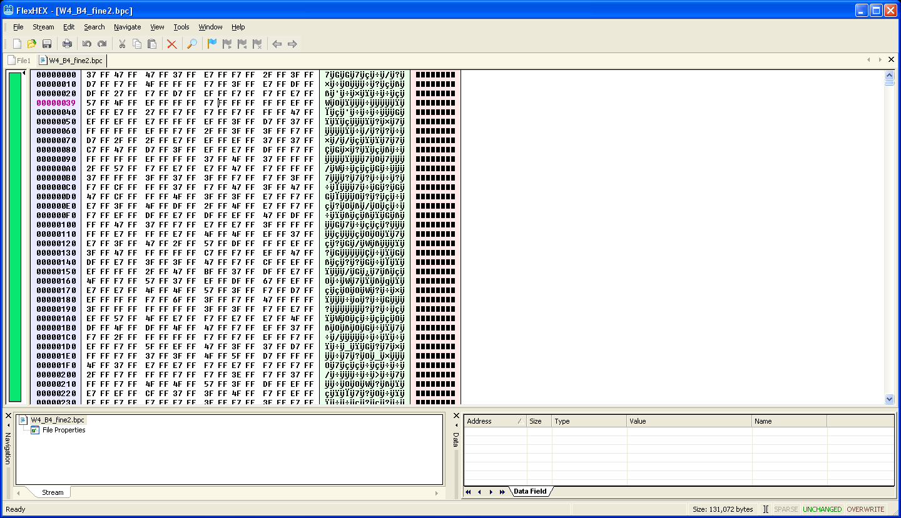

In the example below Gain mode, TestBit and MaskBit are all set to 1 in all pixels:

**IMPORTANT NOTE: the bit values in PIXELMAN format are the invert of the configuration bits described in section 4.1 of the manual. [TBC]**

For operation in Single-Pixel-Mode, the 5 ConfigTHB bits associated with Counter High can be ignored.

The first word of the .bcp files corresponds to the configuration bits of pixel (0,0) at the bottom left corner of the MEDIPIX chip next to the first wire-bond pad.

The second word of the .bpc file corresponds the next pixel to the right: pixel (0,1) and so on…

The value of configuration bits of the first pixel of the second row is therefore stored in the 257th word of the .bpc file.

# Software overview:

EPICS driver

Additional MPX3 commands (i.e. for threshold equalization)

Generic MPX3 commands

MXBP-specific commands

TCP/IP socket connection

MXBP

# Generic Commands to be supplied by MXBP API to EPICS driver through TCP/IP socket:

The commands are specified in TDI-CTRL-TNO-0041.

The following table summarises the API commands and adds extra information related to the use of MEDIPIX3.1 chips in the XBPM system

|  |  |  |
| --- | --- | --- |
| **Command** | **MPX3.1-based XBPM application** | **Command already implemented in EPICS driver** |
| GETSOFTWAREREVISION | YES | YES |
| STARTACQUISITION | YES | YES |
| STOPACQUISITION | YES | YES |
| ABORT | YES | YES |
| SELFTEST | NO | NO |
| NOISEEQUALISATION | NO | NO |
| FLATFIELDCORRECTION | NO | NO |
| THSCAN | YES | YES |
| RESET | NO | NO |
| COLOURMODE | NO. Always 0 for SPM (or monochrome mode). Colour mode is not used in 3.1 | NO |
| CHARGESUMMING | NO. Always 0 (Off). Charge-summing Mode is not used in 3.1 | NO |
| HIGHGAIN | NO. Always at 0 for the range of X-ray energy 5 to 30 keV | NO |
| CONTINUOUSRW | NO. Always 0 (OFF) | NO |
| ENABLECOUNTER1 | NO. Optional: Used for energy windowing: counter 1 with Low Threshold and counter 2 with High Threshold  2 images subtracted off line | NO |
| THRESHOLD0 | YES | YES |
| THRESHOLD1 | YES. Optional: used for energy windowing mode | YES |
| THRESHOLD2 | YES | NO |
| THRESHOLD3 | YES | NO |
| THRESHOLD4 | YES | NO |
| THRESHOLD5 | YES | NO |
| THRESHOLD6 | YES | NO |
| THRESHOLD7 | YES | NO |
| OPERATINGENERGY | YES | YES |
| TESTPULSE | YES | ? |
| COUNTERDEPTH | YES but 12b only | YES but 12b or 24b only |
| NUMFRAMESTOACQUIRE | YES | YES |
| ACQUISITIONTIME | YES | YES |
| ACQUISITIONPERIOD | YES | YES |
| TRIGGERSTART | YES. But only accepts value 0 (internal trigger) at the moment. | YES |
| TRIGGERSTOP | YES. But only accepts value 0 (internal trigger) at the moment. | YES |
| NUMFRAMESPERTRIGGER | YES. But only as a dummy set/get command at the moment. | YES |
| THSCAN | YES | YES |
| THWINDOWMODE | NO. | NO |
| THWINDOWSIZE | NO. | NO |
| THSTART | YES | YES |
| THSTOP | YES | YES |
| THSTEP | YES | YES |
| FILEDIRECTORY | NO | NO |
| FILENAME | NO | NO |
| FILEFORMAT | NO | NO |
| FLATFIELDCORRECTION | NO | NO |
| DEADTIMECORRECTION | NO | NO |
| MASKINDATA | NO | NO |
| DACFILE | YES | NO |
| PIXELMATRIXFILE | YES | NO |
| DETECTORSTATUS | YES - changed to an unsigned integer value (sent as ASCII text) whose bits represent the following status flags:  Bit 0 – detector idle (0) / busy (1)  Bit 1 – pressure normal (0) / high (1)  Bit 2 – cooling ok (0) / failed (1)  Bit 3 – FBK ok(0) / out-of-range (1)  Bit 4 – HV ok (0) / failed (1))  Bit 5 – detector ok (0) / failed to configure properly (1) | YES |

# Additional commands specific to the beam-profiling application to be added to the list of MXBP/EPICS TCP/IP socket commands

|  |  |  |  |
| --- | --- | --- | --- |
| **Command** | **Type** | **Format** | **Description** |
| Image profiles acquisition | | | |
| PROFILES | SET/GET/CMD | 0 - 65535 | Every bit corresponds to the data to be included in profile package:  Bit 0 – image  Bit 1 – raw X profile  Bit 2 – raw Y profile  Bit 3 – I0 (image sum)  The server should ensure that all bits of PROFILES are not zero at the same time. It is suggested that, if the client attempts to set PROFILES = 0, the server enforces a default value (currently 0x06 ­­– bit 1 and 2 are non-zero).  CMD command starts profile acquisition. The profile data will be sent via the data channel in the package with type P12 or P24 (instead of 12B and 24B respectively), for example:  *MPX,<length>,P12,<ASCII Header><Data load>*  ASCII Header is an extension of the Data Frame Header:  *<frame_number>,<counter_number>,<start_time>,<duration>,<Th0>,<Th1>,<DAC001>,<DAC002> … <DAC025>,<profile_select>*  <profile_select> is 5 characters wide ASCII representation of PROFILES  <Data load> contains the binary data sent in little-endian integer format:  *<pixel data 65536 × 16(32 for P24 package) bit><X profile data 256 × 64 bit><Y profile data 256 × 64 bit><I0 1 × 64 bit>*  The fields are only present in the data load if the corresponding bit of profile_select in the Data Frame Header is not zero. |
| IMGONPROFILEN | SET/GET | 0 – LONG_MAX | If non-zero, then a full image will be included in the profile package every Nth frame even if bit 0 of PROFILES is not set. |

# Additional commands to be added to the MXBP API for compatibility with MatLab scripts running on MERLIN

|  |  |  |  |
| --- | --- | --- | --- |
| **Command** | **Type** | **Format** | **Description** |
| DACS | SET/GET | String. | String containing comma-separated DAC values in text format:  <DAC1>,<DAC1>,…<DAC25>  For example: 30,0,0,0,…,10,128,255 |
| PIXELCONFIG | SET/GET | 256 × 256 16-bit binary | Array of 16-bit values arranged in the same way as in PIXELMAN .bpc files |
| DACSAVEDEFAULT | CMD |  | Save current DAC values (including external DAC selection and value for ExtDAC_In pin) to be used as default on camera start-up. |
| DACLOADDEFAULT | CMD |  | Load DAC values (including external DAC selection and value for ExtDAC_In pin) saved as default. |
| DACSAVEFACTORY | CMD |  | Save current DAC values (including external DAC selection and value for ExtDAC_In pin) as factory settings that are used when there are no saved user default settings. |
| DACLOADFACTORY | CMD |  | Load factory DAC values (including external DAC selection and value for ExtDAC_In pin). |
| PIXELCONFIGSAVEDEFAULT | CMD |  | Save current pixel matrix configuration to be used as default on camera start-up |
| PIXELCONFIGLOADDEFAULT | CMD |  | Load default pixel matrix configuration |
| PIXELCONFIGSAVEFACTORY | CMD |  | Save current pixel matrix configuration as factory values that are used when there are no saved default values |
| PIXELCONFIGLOADFACTORY | CMD |  | Load factory values of pixel matrix configuration |
| PIXELMASK | SET | String | Set/Get pixels’ mask bit. 256 × 256 ASCII numbers (code 30 (0) or 31 (1)) separated by a space (ASCII code 20) and each row (after 256 elements) is separated by a carriage return (ASCII code 0A). Pixel 0,0 is the first value entered with the data being uploaded row wise |
| PIXELTEST | SET | String | Set/Get pixels’ test bit. 256 × 256 ASCII numbers (code 30 (0) or 31 (1)) separated by a space (ASCII code 20) and each row (after 256 elements) is separated by a carriage return (ASCII code 0A). Pixel 0,0 is the first value entered with the data being uploaded row wise |
| PIXELTRIM | SET | 256 × 256 × 2 8-bit binary values (0 – 31) | Set/Get pixel’s equalisation numbers. Format:  [pixel0,0 trim0 byte ][pixel0,0 trim1 byte][pixel1,0 trim0 byte]… [pixel255,255 trim1 byte]  Where each [] denotes a byte with a value. There are no delimiters between the binary values. The first data point is pixel 0,0 with the data being entered row-wise |
| ENERGYTODAC | SET/GET | <floating point number>:<floating point number> | Set/Get coefficients for converting energy value to DAC codes (DAC = A + energy * B). Format:  <A>:<B>  Both A and B are text representation of floating point number in scientific format with mantissa’s precision 5. |

# Additional MXBP API commands

|  |  |  |  |
| --- | --- | --- | --- |
| **Medipix DAC monitoring** | | | |
| DACREADSELECT | SET/GET | 0 - 29 | The code of a DAC to monitor through DAC_Out pad. See section 5.3.3 (Selection and monitoring logic) of Medipix3 manual v1.9. Use 0 – to disable monitoring |
| DACREAD | GET | 0 – 3.300 | Fixed point format, in V. The voltage measured on DAC_Out pad. |
| EXTDACSELECT | SET/GET | 0 - 25 | The code of a DAC to bypass through ExtDAC_In pad. See section 5.3.3 (Selection and monitoring logic) of Medipix3 manual v1.9. Use 0 – to disable bypassing |
| EXTDAC | SET/GET | 0 – 1.500 | Fixed point format, in V. The voltage to set on ExtDAC_In pad using the external DAC |
| FBKAUTO | SET/GET | 0 – 1 | Enables (1) / disables (0) automatic adjustment of FBK DAC voltage |
| FBKTARGET | SET/GET | 0 – 1.500 | Fixed point format, in V. The target FBK voltage. Used if FBKAUTO is 1. |
| FBK | GET | 0 – 1.500 | Fixed point format, in V. The measured FBK voltage. |
| FBKTOLERANCE | SET/GET | 0 ­– FLOAT_MAX | Fixed point format, in V. Defines the interval of accepted FBK values within which no FBK DAC corrections are made. This interval is defined as (FBKTARGET - FBKTOLERANCE, FBKTARGET + FBKTOLERANCE). |
| **Detector bias (high voltage) control** | | | |
| HVON | SET/GET | 0 – 1 | Enable (1) / disable (0) detector high voltage. On power-up HVON is always 0. |
| HV | SET/GET | 0 – 200 | High voltage settings |
| HVMON | GET | 0 – 200.0 | Fixed point format. Measured high voltage. |
| VACUUM | GET | 260.0 – 1260.0 | Scientific format, in mbar. Measured vacuum pressure. |
| VACUUMMIN | SET/GET | 260.0 – 1260.0 | Scientific format, in mbar. The minimum vacuum (max pressure) at which the HV supply will be cut off. |
| **Detector cooling subsystem** | | | |
| PELTIERON | SET/GET | 0 – 1 | Enable (1) / disable (0) Peltier cooling |
| PELTIERTEMPTARGET | SET/GET | -40.0 - +100.0 | Scientific format, in °C. The desired temperature of Peltier cold side (detector temperature). Enable Peltier PID controller when using this command. |
| PELTIERTEMPMAX | SET/GET | -40.0 - +100.0 | Scientific format, in °C. Specifies the maximum temperature of Peltier hot side at which, if reached, the Peltier supply will be cut off. |
| PELTIER | SET/GET | 1.83 – 7.99 | Fixed point format, in volts. Sets Peltier voltage directly. |
| PELTIERPID | SET/GET | <Kp> <Ki> <Kd> | Space separated (ASCII code 0x20) fixed point values of PID coefficients for Peltier PID controller. |
| PELTIERPIDON | SET/GET | 0 – 1 | Enable (1) / disable (0) Peltier PID controller. If zero, use PELTIER command to set Peltier supply voltage. |
| PELTIERPIDWUP | SET/GET | 0 ­– FLOAT_MAX | Scientific format, in volts. Wind-up limit on PID integral term. |
| PELTIERPIDTMPSTEP | SET/GET | 0 ­– FLOAT_MAX | Scientific format, in °C. Defines the maximum allowed difference between the required and current temperature of the Peltier cold side that is used as the input to the Peltier PID controller. |
| PELTIERPIDPERIOD | SET/GET | 0 ­– FLOAT_MAX | Scientific format, in seconds. The PID period used in calculations of PID integral and differential terms. |
| PELTIERFANTMP | SET/GET | 0 - 124 | Integer, in °C. The temperature of the Peltier hot side at which the fan is started at its minimum speed. |
| PELTIERFANTMPRNG | SET/GET | 5 - 80 | Integer, in °C. The size of the interval of temperatures within which the fan speed is varied from minimum to maximum. |
| **Other commands and variables** | | | |
| TEMPERATURE | GET | -40.0 - +100.0 | Scientific format, in °C. The sequence of 5 values separated by space (ASCII code 20):  <detector> <peltier_cold> <peltier_hot> <detector_board> <interface_board> <detector_board_pressure>  <detector> – Medipix3 temperature measured by monitoring Band_Gap Temperature and Band_Gap Output internal monitoring signals (see Medipix3 manual, v1.9);  <peltier_cold> and <peltier_hot> – temperatures of the cold and hot sides of Peltier respectively;  <detector_board> and <interface_board> – temperatures measured on electronics boards carrying the detector and supporting electronics respectively;  <detector_board_pressure> – temperature measured by the sensor inside the pressure sensor on the detector board; |
| TESTPULSENUM | SET/GET | Positive integer | Number of test pulses per counting time. Limited by the detector clock frequency (currently 60 MHz). Used when TESTPULSE is 1. |
| TESTREFA | SET/GET | 0 – 999.99 | TP_REFA value in keV (current implementation is a stub which uses ENERGYTODAC coefficient to calculate keV values similar to THRESHOLD<N> and OPERATINGENERGY commands) |
| TESTREFB | SET/GET | 0 – 999.99 | TP_REFB value in keV (current implementation is a stub which uses ENERGYTODAC coefficient to calculate keV values similar to THRESHOLD<N> and OPERATINGENERGY commands) |
| SAVESETTINGSASDEFAULT | CMD |  | Saves the following settings as default (used on power-up):  DACREADSELECT,  FBKAUTO,  FBKTARGET,  FBKTOLERANCE,  HV,  PELTIERON,  PELTIERTEMPTARGET,  PELTIERTEMPMAX,  PELTIER,  PELTIERFANTMP,  PELTIERFANTMPRNG,  PELTIERPIDON,  PELTIERPID,  PELTIERPIDWUP,  PELTIERPIDTMPSTEP,  PELTIERPIDPERIOD,  VACUUMMIN,  ENERGYTODAC,  TESTPULSENUM. |

**CNM/GLASGOW/DLS 3D Quad sensor layout detail**

The overall size of a 3D quad is 31000 microns x 29800 microns from the dicing lane on one side to the dicing lane on the other side as shown in Copia de cnm425.gds.

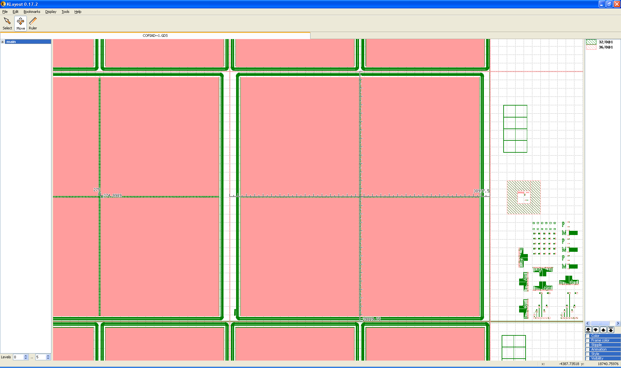

The distance between the centres of the pixels at the perimeter of each MPX3 die is **275 microns** as shown in Copia de cnm425.gds.

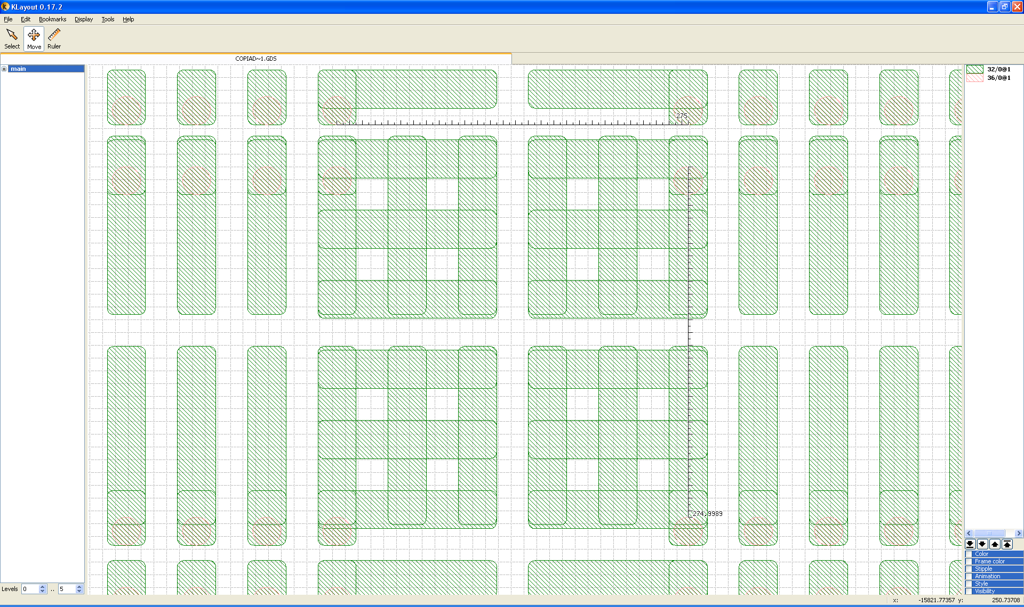

This spacing results in **4 “virtual pixels of 55 microns”** in the gap between 2 MPX3 dies.

**EXCALBUR wafer quad sensor layout detail**

The overall size of an EXCALIBUR wafer quad is 30200 microns x 30200 microns from the dicing lane on one side to the dicing lane on the other side.

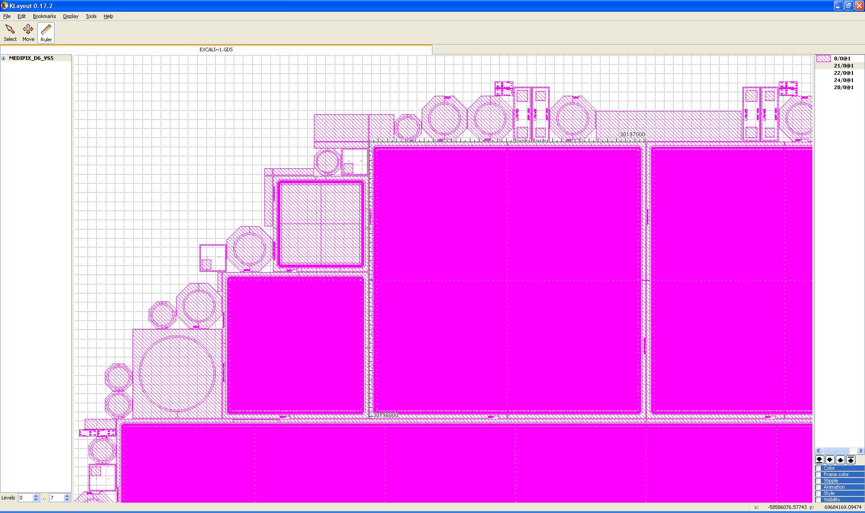

The distance between the centres of the pixels at the perimeter of each MPX3 die is **220 microns**

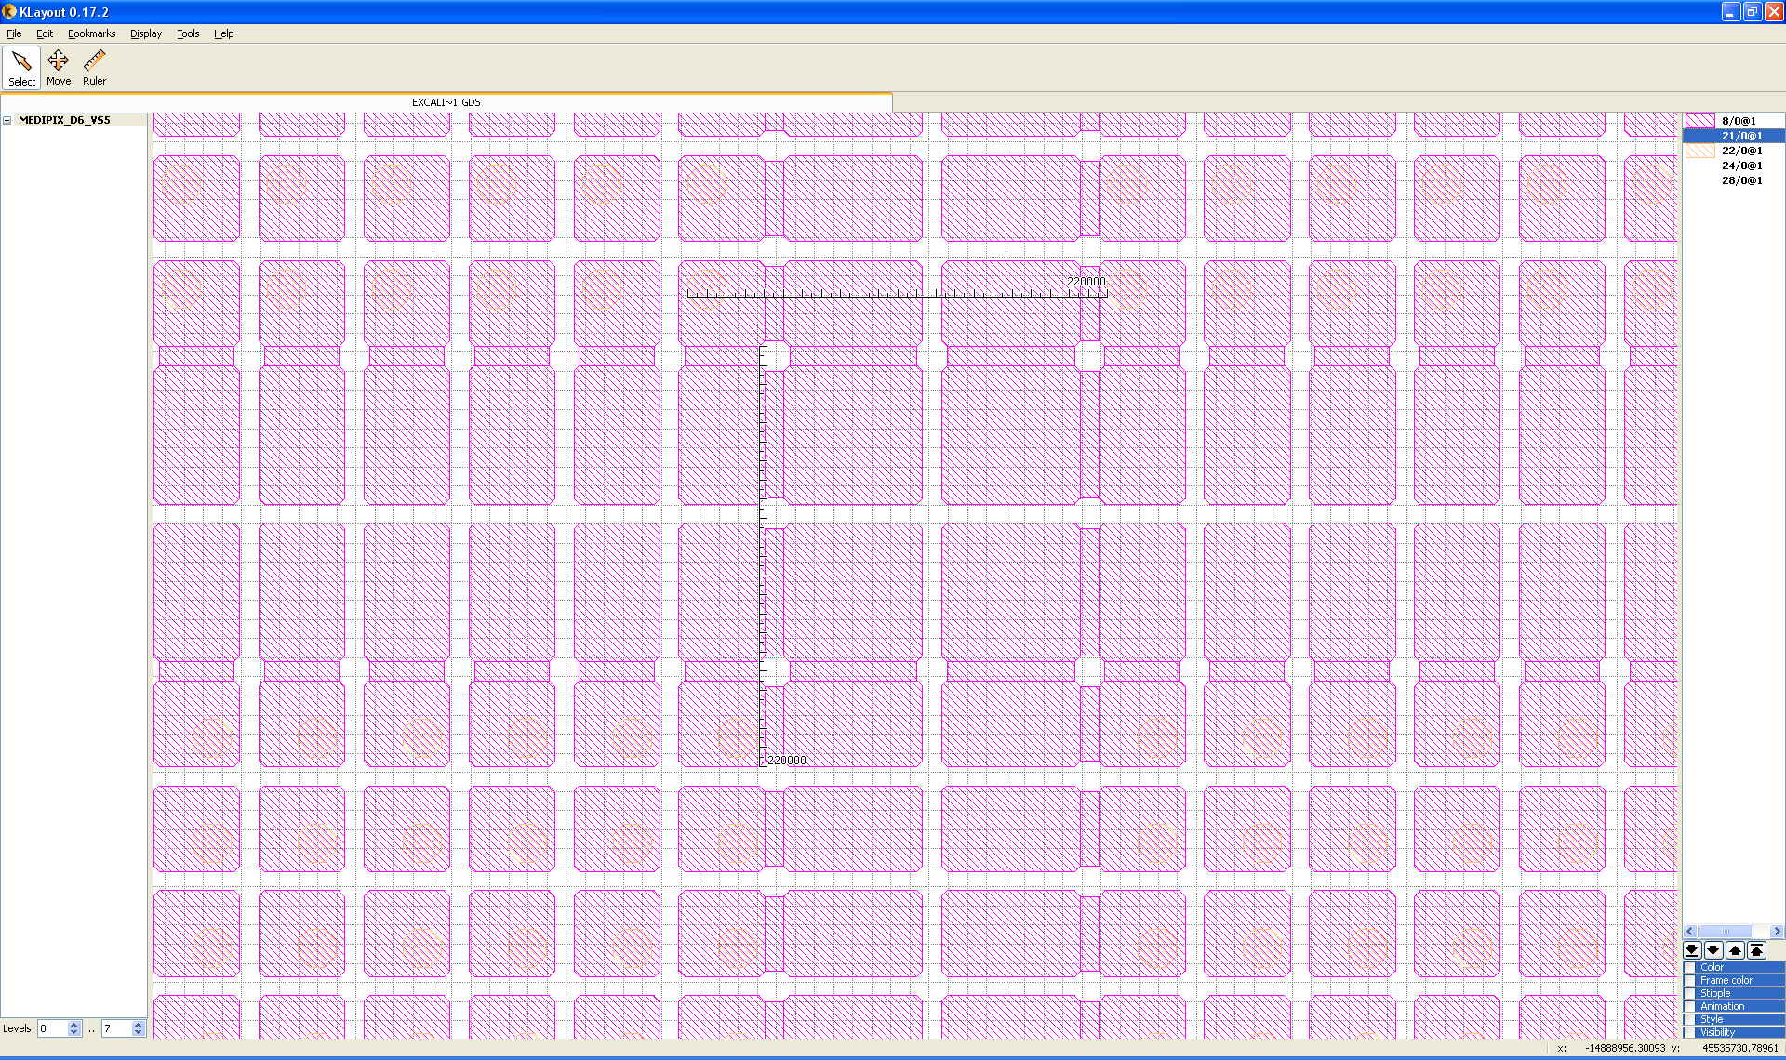

This spacing results in **3 “virtual pixels of 55 microns”** in the gap between 2 MPX3 dies.

**IMPORTANT NOTE:**

The position of the bump-pad in array with respect to the Silicon pixel array is different from the one used in the 3D quads. **NOTE that this is the bump-pad array which determines the position of the MEDIPIX chips.**

**Quad Sensor spacing detail**

Medipix3.1 die is 14.1x17.3mm2 and will have a full circuit board GND pad of exactly the same size. The Medipix die allows forming a larger array using three of its four sides. The quad sensor board will hold four dies spaced with 220 micrometre between the centres of the pixels at the perimeter of each die.

M2

M1

M4

M3

Pixel centre-to-centre distance

(horizontal & vertical):

220 micrometre

Medipix pixel

Sensor die numbering scheme is indicated (M1-4) when looking from above (top view).

**Quad Sensor circuit board**

The quad sensor board will hold all circuits needed to operate up to four dies. It will be of rectangular shape with the narrowest dimension 28.6mm, which allows boards to be stacked to create larger arrays with minimal gap. It will be of flex-rigid design and provide direct connections to either two VHDCI (68pin) or two sub-D (50pin) female connectors.

**Labview GUI functionality**

Overall concept: A main window common to USER and EXPERT mode.

A secondary window with 2 menus: XBPM and Energy Spectrum in USER MODE

More menus available in the secondary window when switching to EXPERT MODE

XBPM

Spectrum

**USER MODE**

System settings

1 D x-profile display

1D y-profile display

Live view

Acquisition settings

Frame saving

START

Statistics

Frame display panel

Masking

Frame loading

XBPM

Equalization

Start-up

Test

ASIC

System

Spectrum

**EXPERT MODE**

System settings

Global settings

DACS

Live view

Acquisition settings

Specific DAC settings

Frame saving

Frame display panel

Pixel configuration

Frame loading

**Generic window functionality:** only important detector parameters + 2D image display

|  |  |  |
| --- | --- | --- |
| **Panel** | **Functions** | **Panel items** |
| **System settings** | LV Power | LV Power ON STATUS LED on panel |
| HV Power | HV Power ON STATUS LED on panel + HV reading |
| Peltier power and temp | Peltier Power ON STATUS LED on panel + PELTIER TEMP reading |
| Pressure reading | Vacuum OK STATUS LED on panel + PRESSURE reading |
| Acquisition running | Acquisition running STATUS LED with IMAGE COUNT DOWN showing how many more images need to be taken (by groups of 100s if the required number of images is >100). |
| Abort | Abort acquisition push button |
| **2D image display** | Info about image sequence being displayed | The image display is used in different situations:  # LIVEVIEW (cf LIVEVIEW section)  # IMAGE ACQUISITION WITHOUT DATA SAVING  # IMAGE ACQUISTION WITH DATA SAVING  # IMAGE LOADING  # TO SHOW THE MASK USED FOR STATS  # TO SHOW PIXEL CONFIG BITS FROM THE ASIC MENU IN EXPERT MODE  The functionality needed is simply:  # + and – buttons to browse a sequence of frames  # image path and name selection and display  In LIVEVIEW and IMAGE ACQUISITION WITHOUT DATA SAVING this is disabled  In IMAGE ACQUISTION, it is automatically updated with the image name which was selected by the user in the saving settings.  # Option to save the image being displayed |
| Zoom | # Possibility of zooming in and out the image  # Quick way of zooming back to original view  # Tick-box to switch to FULL SCREEN VIEW of the display when acquiring or running live view |
| Contrast | # Display should be done using the Power Law method:  Gray_Value*((pixel_count - MIN)/(MAX MIN))*(SCALING FACTOR/15)  Where the parameters chosen by the user are:  MIN  MAX  SCALING FACTOR (up to 15).  # Boxes need to be present to enter exact values of MIN, MAX and SCALING FACTOR.  # Depending on space available sliders can also be added for MIN, MAX and SCALING FACTOR. These sliders and the box values need to be synchronized.  # Possibility for autoscaling should be present.  ( AUTOSCALE tick box)  A simple MIN-MAX autoscale is acceptable;  *# Optional: smart autoscaling (for example discarding hot pixels) could also be implemented.*  # Colormap: No need for many fancy colour maps selection. A good colourful colour map to start is enough.  # Show pixel coordinates and value: X, Y, COUNT |
| Roi | # Possibility of selecting a square ROI on the display.  Selection via boxes:  ROI Start X,  ROI Start Y  ROI width in X  ROI width in Y  If selected, this ROI will be used for calculating statistics  # The ROI selection can be done by unfolding a menu so that it does not take space on the GUI when no ROI is needed.  *# Optional: manual selection with cursor*  *# Optional: circular ROI* |
| **Acquisition settings** |  | # NUMBER OF TRIGGERS  # NUMBER OF FRAMES PER TRIGGER  # EXPOSURE TIME  # EXPOSURE PERIOD / FRAME RATE/ GAP TIME (500ms min)  I think it would be a good idea to show these 3 parameters all the time. Each time 1 of these 3 is changed, the 2 others should be automatically updated.  For example: exposure time is set at 1ms by the user.  Then automatically the GUI puts:  frame rate = 666fps/ exposure period = 1.5ms /gap time = 500 ms  these are the fastest possible values assuming a read-out time of 500ms (it will have to be adjusted depending on the performance of the system).  The user can then choose to slow down the read-out by playing either with the frame rate, the exposure time or the gap time.  # DELAY  # A tick box is needed to lock the frame rate /exposure period/gap time (500ms min) settings if the user wants to play with exposure time at constant frame-rate.  # INTEGRAL MODE tick box(keeps summing up images)  # DETECTION THRESHOLD (in keV and DAC units in case no calibration is present)  # TRIGGER (software/hardware)  # START ACQUISITON  # A clear LIVEVIEW push button should be provided.  This has to be used when the user just want to see an image quickly without bothering about what’s going on in the detector  When LIVEVIEW is ON: ONLY ONE DETECTOR ADQUISITION PARAMETER needs to be used:  # EXPOSURE TIME  All other parameters should be shaded.  The detector should acquire at the fastest frame rate possible (FRAME RATE=1/[EXPOSURE TIME + 0.5 ms`]) but display images at a display rate of 5 images per second if the or more if the exposure time is set to more than 200 |
| **File saving settings** |  | # IMAGE SAVING tick box  # PATH  # FILENAME  Filenames should be auto-incremented  We should discuss whether we want another tick box to allow data to be overwritten |

**XBPM and spectrum tabs available in USER MODE and EXPERT MODE**

In user mode only the XBPM tab and Spectrum tab are available

|  |  |  |
| --- | --- | --- |
| **Tab** | **Panel** | **Panel items** |
| **XBPM** | 1D profiles | 1D projection in X |
| 1D projection in Y |
| Statistics | Mean (= I0 value ?), sigma, min and max over selected ROI (or all image if no ROI selected)  Option to select a mask file:  MASK PATH  MASK FILENAME  USE MASK tick box |
| Masking | Pixel masking tab: tab for creating a mask to be used for statistics.  This is NOT a mask to be loaded in the ASIC but only a mask to be used when calculating image statistics.  Several Options should be offered: add the coordinates of a pixel ROI to the mask or mask every pixel of the current image with counts above a value selected by the user. |
| **Energy**  **Spectrum** | Spectrum tab performing a TH0 DAC scan and differentiating the result and plotting as a function of threshold in keV units. | 1 D display of TH0 DAC scan  Option to display integral or differential spectrum  Option for holding plots on same figure  Option for saving spectrum  Start DAC (keV or DAC value)  Stop DAC (keV or DAC value)  Step DAC (keV or DAC value)  Current DAC value should be updated in the THRESHOLD VALUE of the main GUI window. |

**EXPERT MODE additional functionality**

|  |  |  |
| --- | --- | --- |
| **Tab** | **Panel** | **Panel items** |
| **XBPM** | Same as user mode |  |
| **Energy Spectrum** | Same as user mode |  |
| **System** | Read-out board | Control parameters related the read-out electronics board, board ID, firmware versions, self test…  Log of TCP/IP communications |
| Peltier and vacuum | # Peltier control:  PELTIER ON/OFF  PELTIER TEMP TARGET  PELTIER TEMP READING  # Vacuum  PRESSURE READING  # Values for temperature and vacuum limits (used to interlock HV and chip LV power)  PRESSURE MIN  PELTIER TEMP MAX |
| ASIC LV | I and V readings  LV ON/OFF |
| Sensor HV | HV ON/OFF  HV setting  I and HV readings |
| ASIC temp | Reading of ASIC temp via DACs: ASIC TEMP |
| **ASIC** | Global settings | ASIC ID number e.g. W1_C2  and type ?: MPX3.0,1 or RX  BIT DEPTH  READ OUT MODE  ACQUISITION MODE  GAIN  POLARITY |
| DAC settings | Allows to set and read-back DACs: 25 SET DACS and 25 READBACKS  Readings should be refreshed regularly |
| Specific DAC settings | EXT DAC SELECTION: Allows to point DAC IN analogue signal to any DAC.  By default it should be set to CAS.  SET EXT DAC: set the value of the external DAC  By default it should be set at 0.65 for CAS.  Optional:  SENSE DAC SELECTION: Select a specific DAC  SENSE DAC READING: read the selected DAC  FBK AUTO-ADJUST: Tick box to enable FBK automatic adjustment.  FBK TARGET VALUE: 0.85 by default |
| Pixel configuration | Read-backs pixel configuration file:  SHOW CURRENT MASK BITS  SHOW CURRENT TEST BITS SHOW CURRENT TH0 ADJ BITS  SHOW CURRENT TH1 ADJ BITS  Configuration matrixes are displayed in the main window  LOAD NEW .bpc file and associated DACs  SAVE NEW .bpc file and associated DACs  EDIT CURRENT CONFIGURATION: possibility of adding pixels to the mask file or to change the TH ADJ value for a pixel or a group of pixels. |
| **Test** | Digital test | To be defined later |
| Test pulse | NUMBER OF PULSES  REF A in keV  REF B in keV  TEST PATTERN FILE  START PULSES |
| DAC scan | Same as Spectrum but any DAC can be selected |
| **Start-up** |  | Location of .dac file and .bpc file to be used at start-up.  Selection of default settings to be used in user mode: FBK automatic adjustment enabled, PELTIER temp automatically, HV automatically set…. |
| **Equalization** |  | To be defined later. We will start with off-line equalization. |